**Aim**: Heuristic Evaluation of online news sites

**Introduction**

Today, people (especially the young generation) do not read printed newspapers. They are moving online to read the news. Because more and more people are moving to online news sites for there news, there is a pressing need to look at usability of news sites and to see how the reader experience can be improved. Usability is one of the major factors that determine the successfulness of a website. Here we focus on news website usability issues. In order to evaluate news websites we have chosen the following: Ndtv news ( a typical indian news site), New york times (an international news site), Google News (a more modern news site) and Times of India e-Paper (electronic version of the print news paper). We have done a heuristic evaluation of these websites and presented our findings.

**Usability Evaluation Methods**

Usability is an important aspect of the user interface of any software application. Several studies have shown that in addition to functionality and reliability, usability is a very important success factor. Usability inspection is the generic name for a set of methods that are all based on having evaluators inspect a user interface. Typically, usability inspection is aimed at finding usability problems in the design. The evaluation methods can be summarized into following categories:

1. **Heuristic evaluation:** the most informal method and involves having usability specialists judge whether each dialogue element follows established usability principles.
2. **Heuristic estimation:** a variant in which the inspectors are asked to estimate the relative usability of two (or more) designs in quantitative terms.
3. **Cognitive walkthrough**: uses a more explicitly detailed procedure to simulate a user's problem-solving process at each step through the dialogue, checking if the simulated user's goals and memory content can be assumed to lead to the next correct action.
4. **Pluralistic walkthrough**: uses group meetings where users, developers, and human factors people step through a scenario, discussing each dialogue element.
5. **Feature inspection:** lists sequences of features used to accomplish typical tasks, checks for long sequences, cumbersome steps, steps that would not be natural for users to try, and steps that require extensive knowledge/experience in order to assess a proposed feature set.
6. **Consistency inspection:** has designers who represent multiple other projects inspect an interface to see whether it does things in the same way as their own designs.
7. **Standards inspection**: has an expert on an interface standard inspect the interface for compliance.
8. **Formal usability inspection:** combines individual and group inspections in a six-step procedure with strictly defined roles to with elements of both heuristic evaluation and a simplified form of cognitive walkthroughs.
9. **Objective performance:** measures the capability of the visitors using the website in terms of time taken to complete specific tasks through the system.
10. **Subjective user preferences:** measure the users’ performance preferences to the system by asking them to elicit their opinions or use questionnaire for rating the system.
11. **Experimental:** based on controlled experiments to test hypotheses about design and their impact on user performance and preferences.
12. **Direct observation:** inspect and monitor the users’ behavior while they are interacting with the system to detect usability problems.

**Heuristic Evaluation**

A Heuristic Evaluation is a usability inspection technique where one or a number of usability experts evaluate the user interface of a product (for example a website) against a set of Heuristic Principles (also known as Heuristics).

It is usually conducted by a group of experts because it is very likely that one person will not be able to find all usability problems. On the other hand, a group of different people tend to analyze an interface from different angles and as a result are more likely to identify a wider set of areas for improvement.

Following are some of the principles on which a heuristic evaluation was done for the various news sites.

**Visibility of system status**

The system should always keep users informed about what is going on, through appropriate feedback within reasonable time.

**Evaluation:**

**NDTV Website** generally informs the user in terms of what they are seeing on the page. They inform whether the user is seeing an advertisement or sponsored link or a sponsored article. Sometimes though they fail to do so.

Below are some examples where they keep user informed:

|  |  |
| --- | --- |
|  |  |

Below are examples where they have not informed or user is not sure:





**New York times** does not clearly inform the user if they are seeing an advertisement. Only if the user hovers the mouse over the info icon, will the user see it is a google advertisement





**Google news** informs user of what they are seeing on the page by highlighting the main category and the sections they are in. Here one can see that one is in the Headlines category (underlined and in blue) and India section (shown in bold)

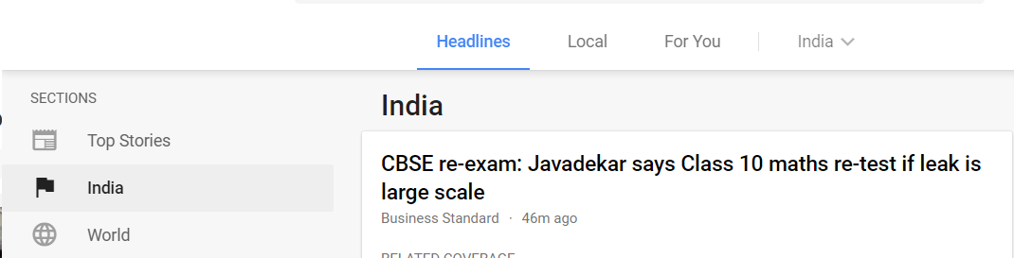

However, since Google News is an aggregator of news, when user clicks on a particular news article, it opens on a new Tab on the browser and Google news does not have any way of indicating to the user where the user is and from where he or she has come in.



**Times of india e-paper** is like an actual paper and provides appropriate feedback. Thus, if user hovers over a page a zoom icon comes up indicating that user can zoom in. Also, appropriate tips are provided to icons. Thus, when user hovers over an icon, the tip comes up.

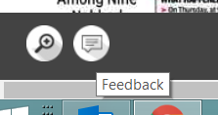

**Match between system and the real world**

The system should speak the users' language, with words, phrases and concepts familiar to the user, rather than system-oriented terms. Follow real-world conventions, making information appear in a natural and logical order.

**Evaluation**

Google News and New York times provide user to change the language. Google News detects the user location and based on location brings up the choice of languages that the user is most likely to choose at the top and other languages at the bottom. New York times provides a limited set of languages. Menu names are consistent with the language chosen. However, the advertisement in New York times remain in English language even if the language is switched.

**Google News – language change**

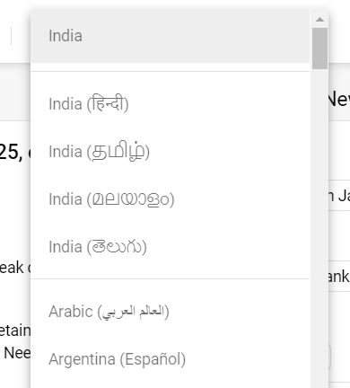

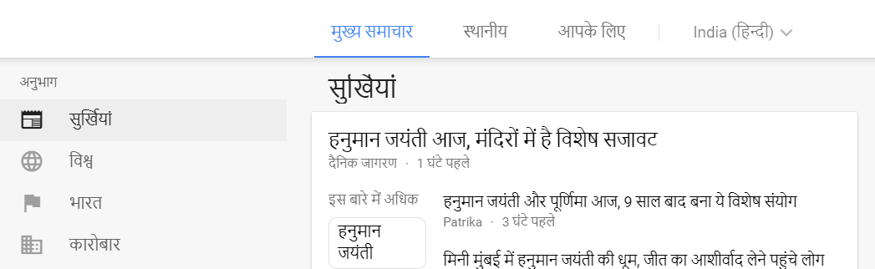

**New York times – language change**

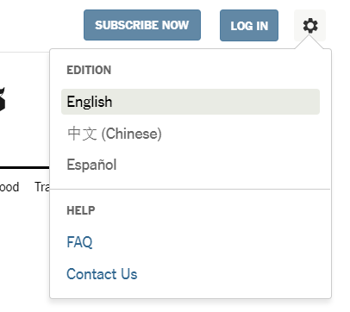



NDTV News and Times of India e-paper does not provide option to change the language.

**User control and freedom**

Users often choose system functions by mistake and will need a clearly marked "emergency exit" to leave the unwanted state without having to go through an extended dialogue. Support undo and redo.

**Evaluation**

On all sites, users generally have a way to go back if a user has chosen an option which he or she wants to go back from.

However, since Google News is an aggregator of news, when user clicks on a particular news article, it opens on a new Tab on the browser. Google news loses control and there is no way, user can go back to Google News other than to close the Tab.

As seen below, the indian express news article has opened in a new Tab outside of Google news.



**Consistency and standards**

Users should not have to wonder whether different words, situations, or actions mean the same thing. Follow platform conventions.

**Evaluation**

All websites are consistent in the use of words or actions. They generally mean the same thing. Generally, for icons also, conventional icons for twitter, facebook etc are used. For other icons, most of the time, it is obvious what the icons mean. However, sometimes the icons are not obvious as shown below.

**NDTV News**

|  |  |
| --- | --- |
|  | This icon looks like some sort of a timer. It is actually one for breaking news. |

**New York Times News**

|  |  |
| --- | --- |
|  | Here though the text is also written along with the icon, the icon, does not look like a home delivery icon. |
|  | Here though the text is also written along with the icon, the icon, does not look like a digital subscriptions icon. |

**New York Times** has also one inconsistency. On the home page, for a user to log in, the option on the screen is **Log In,** where as on the Contact page, the option to log in is **Account.** See screens below.

**Home page**



**Contact Page**

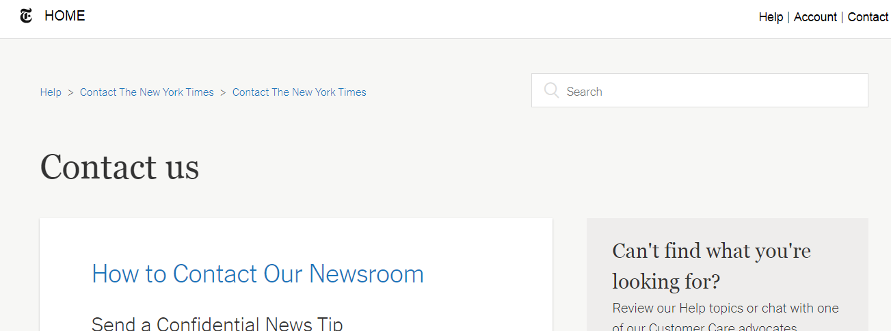

**Error prevention**

Even better than good error messages is a careful design which prevents a problem from occurring in the first place. Either eliminate error-prone conditions or check for them and present users with a confirmation option before they commit to the action.

**Evaluation**

On all web sites, the design prevents a problem from occurring in the first place.

**Recognition rather than recall**

Minimize the user's memory load by making objects, actions, and options visible. The user should not have to remember information from one part of the dialogue to another. Instructions for use of the system should be visible or easily retrievable whenever appropriate.

**Evaluation**

All websites have objects, actions and options visible on all pages. User does not have to remember information from one page to another.

**New York Times’s** FAQ and Contact pages have a very different look from the news page. User would thus get disoriented at times. See below the FAQ and Contact page.

**New York Times FAQ Page**



**New York Times Contact Page**



**Aesthetic and minimalist design**

Pages should not contain information which is irrelevant or rarely needed. Every extra unit of information on a page competes with the relevant units of information and diminishes their relative visibility.

**Evaluation**

In terms of aesthetic and minimalist design, Google News is the best and NDTV News the worst amongst the four.

Google news has a very minimalist design, is aesthetically pleasing without any clutter and consistent. Both New York times and NDTV News try to put a lot of news and other items on the news page. This is overwhelming to the user, cluttered and has too much information for the user. Advertisemnts are also a distraction.

Times of India e-paper has a printed paper look. Thus, those who like printed paper formats will like this. However, one has to zoom in and move around to go through the articles. This can be a bit tedious for the user.

Below are the home page of each news website.

**Google News**

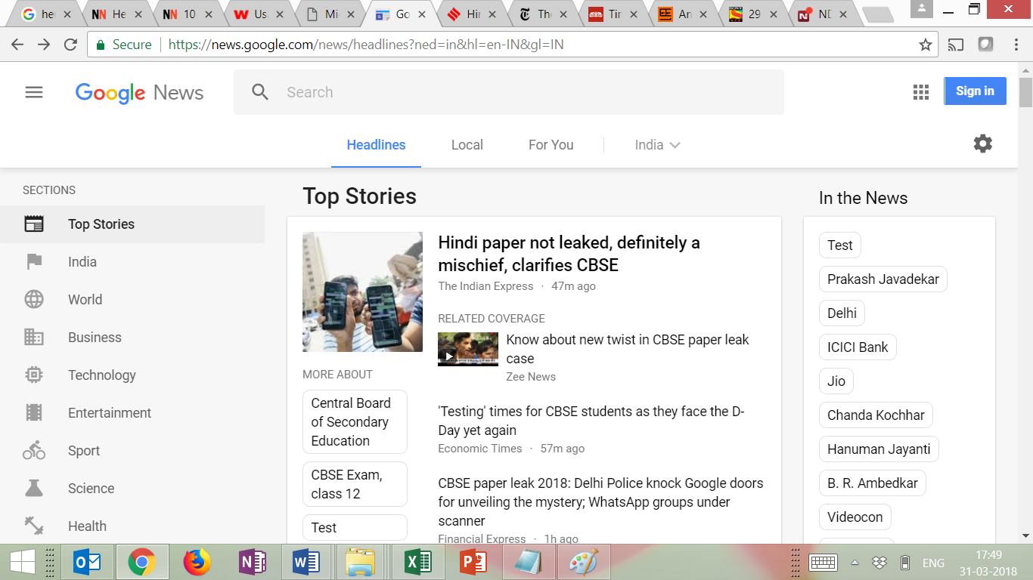

**NDTV News**

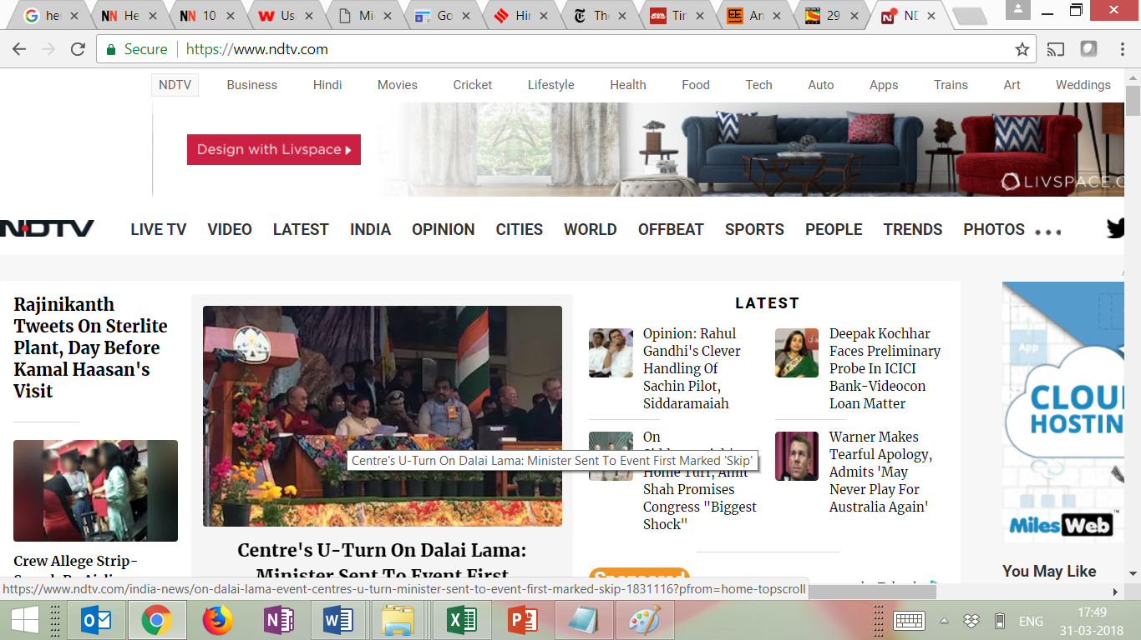

**New York Times**

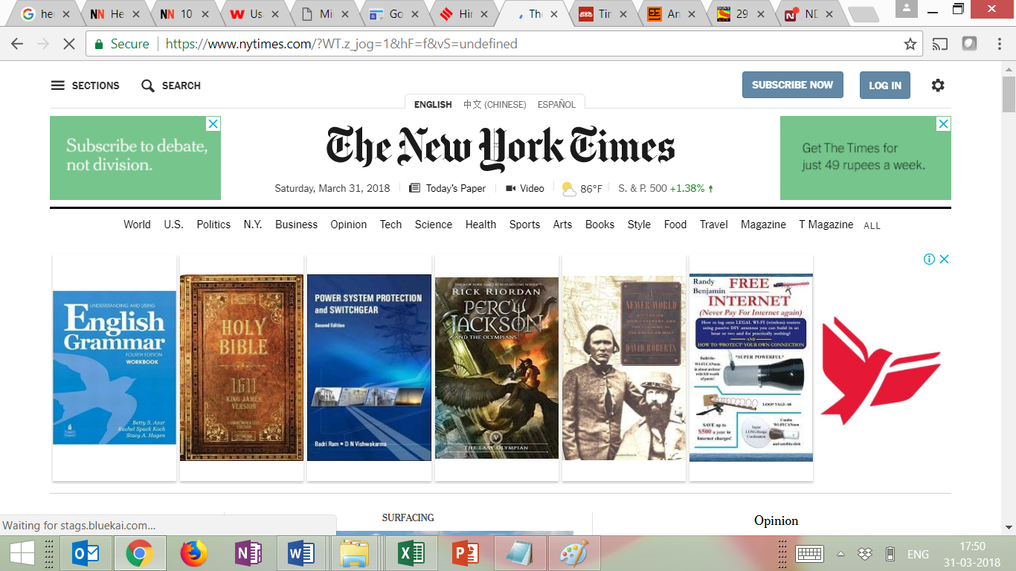

**Times of india e-paper**



**Help and documentation**

Even though it is better if the system can be used without documentation, it may be necessary to provide help and documentation. Any such information should be easy to search, focused on the user's task, list concrete steps to be carried out, and not be too large.

**Evaluation**

Though news websites may not require help, it would be required for users who are not computer literate such as senior citizens and need help to use the website. It may also be useful to experienced users, if the website offers the user the opttion to set preferences in terms of topics or categories of news.

NDTV and Times of India e-paper do not have an help option.

Not having an help option is okay, but having the help option in the menu and not linked to a help page is not good. NewYork times has help in the menu but no link to a help page.

Google News has the best help section.

**New York Times – help with no link to any page**

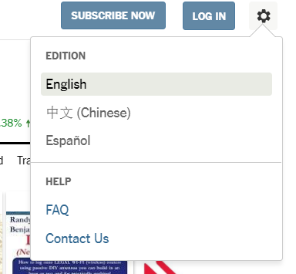

**Google news help page**

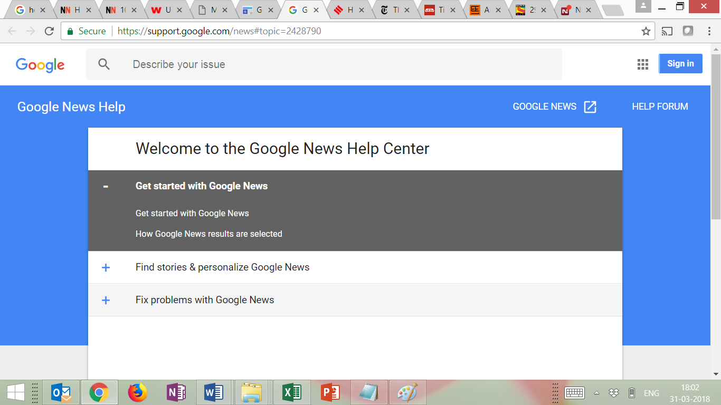

**Users Should Know Where They Are**

Getting lost is not fun. Getting lost in an app or website is even less so. Just like most streets and roads have signs with their name to let pedestrians know where they are, so must user interfaces. If a user is going through a sequence of events, this should be shown somewhere in the design. Moreover, it should not be possible to enter a state from which there is no exit.

**Evaluation**

**Times of India** being an e-paper, user does not lose the way and always knows where the user is.

**New York Times** clearly indicates where the user is currently is. For example in the below screen, user is in the World 🡪 Asia Pacific news section

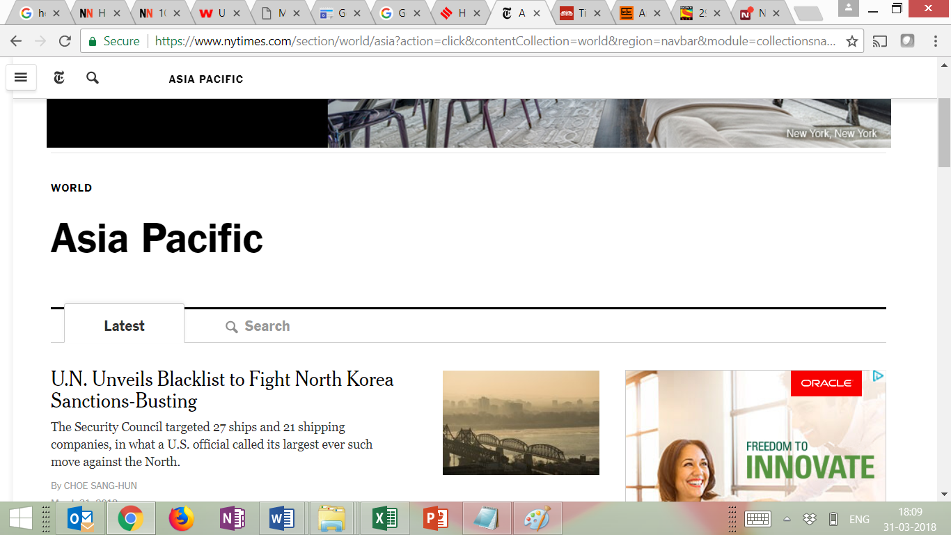

**Google News** Since Google News is an aggregator of news, when user clicks on a particular news article, it opens on a new Tab on the browser. Google news loses control and there is no way, user can go back to Google News other than to close the Tab.

As seen below, the indian express news article has opened in a new Tab outside of Google news.



**NDTV news** most of the time indicates to the user where he or she is. However, it is not consistent. Some examples below.

**Example 1**

Home Page options



User clicks **India.** User sees the below page



Notice, that the breadcrumb shows **HOME | ALL INDIA.** Instead of showing INDIA, it shows ALL INDIA.

User now clicks on the article “Anandi Gopal Joshi….”



Notice that the breadcrumb now shows **HOME | PEOPLE¸** instead of **HOME | INDIA| PEOPLE**

**Example 2**

NDTV News has another news website for technology. Thus, when user clicks a technology news item, the user is taken to a the technology news website which is a totally different interface. User cannot go back from where he or she has come from (except by using the back button on the browser). Home on this page goes to the technology home page and not NDTV home page. Clicking on NDTV takes the user to the NDTV home page and not from where the or she has come to this page.

Following screens show the issue:

**User clicks on LATEST on the NDTV home page**



**User clicks on the technology news article**

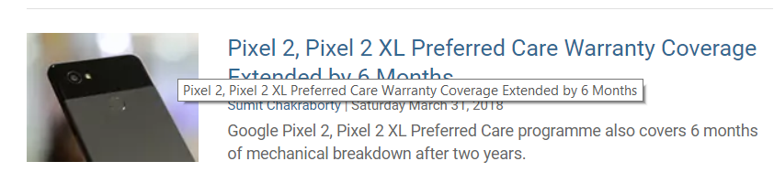

**User is taken to a totally new website**

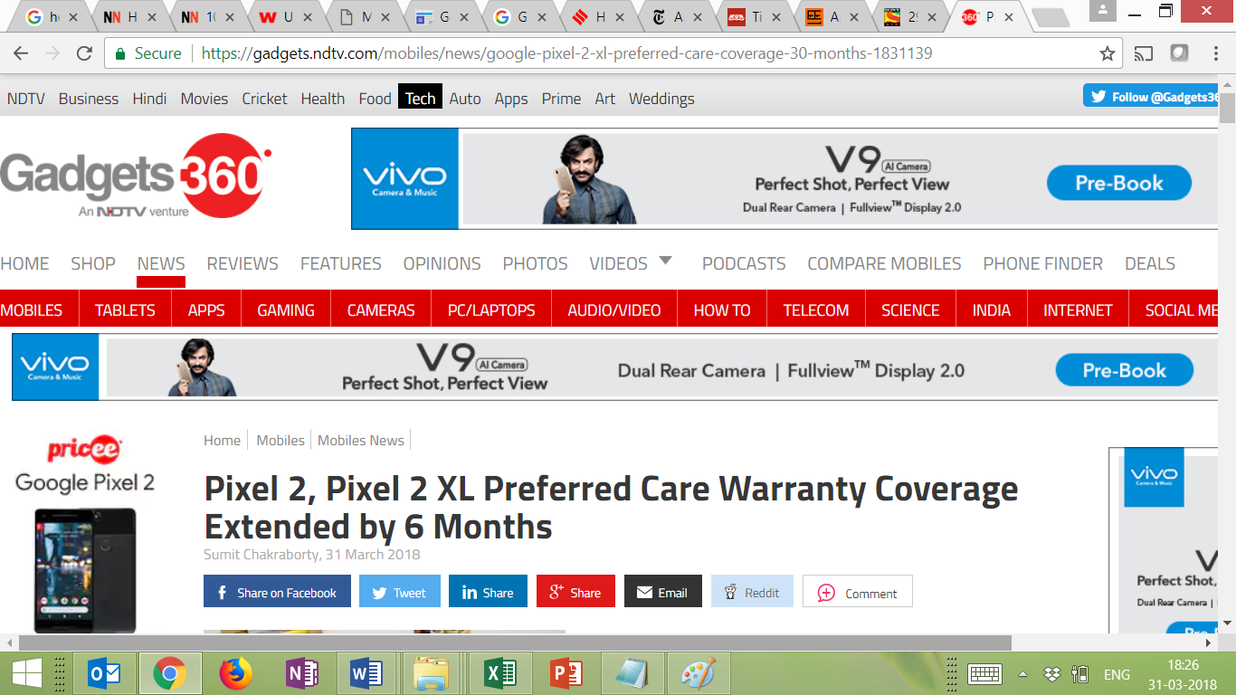



**Summary of heuristic evaluation of the various news websites**

Following is our evaluation of the various news websites taken up. On each of the Heuristic, a score between 0 to 10 is given, with 10 being the highest.

|  |  |  |  |  |  |
| --- | --- | --- | --- | --- | --- |
| **Sr.**  **No.** | **Heuristic** | **NDTV** | **New York Times** | **Google News** | **Times e-Paper** |
| 1 | Visibility of system status | 8 | 6 | 8 | 7 |
| 2 | Match between system and the real world | 5 | 8 | 9 | 5 |
| 3 | User control and freedom | 8 | 8 | 6 | 8 |
| 4 | Consistency and standards | 5 | 6 | 8 | 8 |
| 5 | Error prevention | 8 | 8 | 8 | 8 |
| 6 | Recognition rather than recall | 8 | 7 | 8 | 8 |
| 7 | Aesthetic and minimalist design | 6 | 6 | 9 | 8 |
| 8 | Help and documentation | 7 | 6 | 8 | 7 |
| 9 | Users should know where they are | 7 | 8 | 7 | 8 |
|  | **Total** | **62** | **63** | **71** | **67** |

**Conclusion**

After the comparison of 4 websites we have concluded that Google news is the best website for from user experience perspective. It has a very clean, uncluttered layout with proper sections and help and also since it is add free it is much pleasant to go through the news.